Assignment1 - Vaishnavi Vinayak Sawant

1. Windows Server Instance

Public IP-13.58.64.46

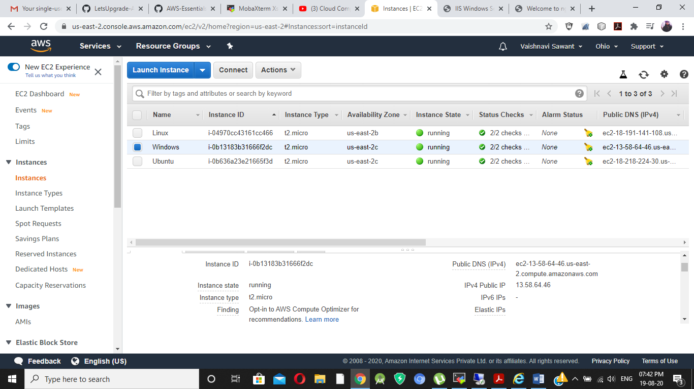

IIS Windows Server

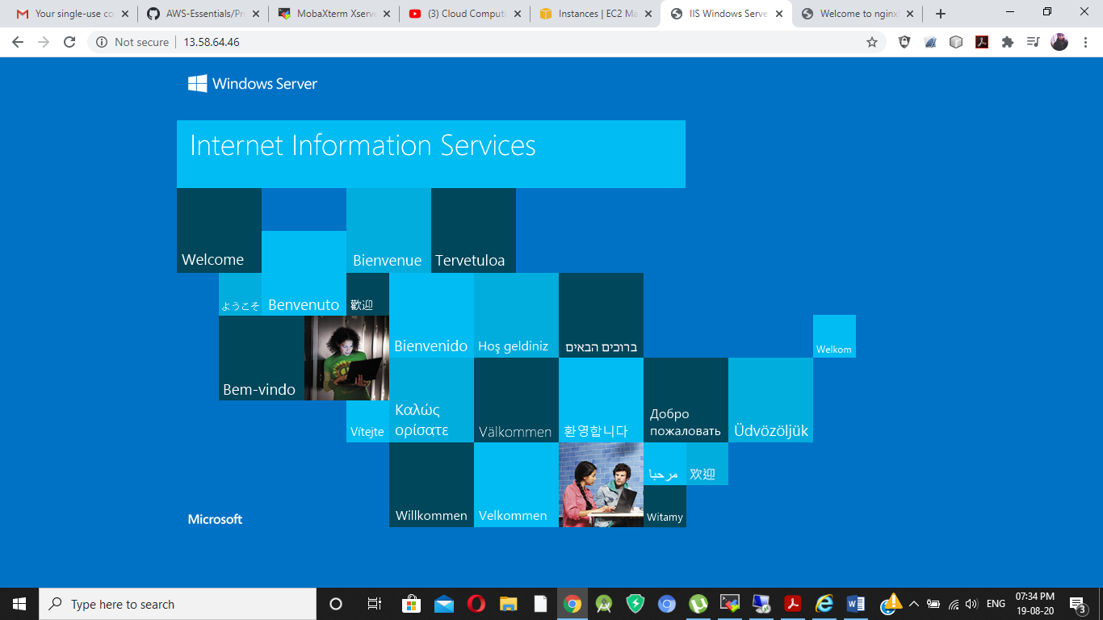

1. Ubuntu Server Instance

Public IP - 18.218.224.30

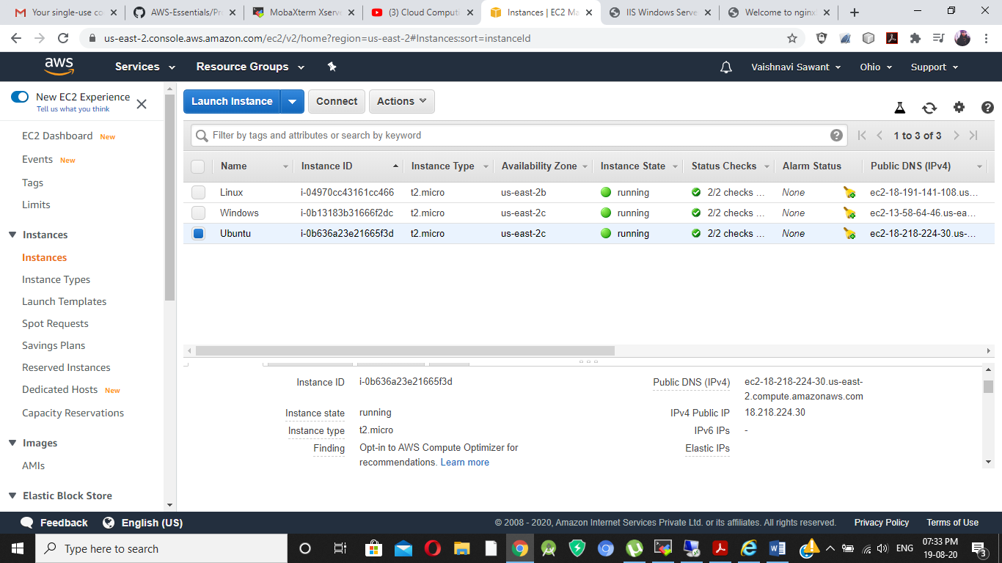

Nginx Installation

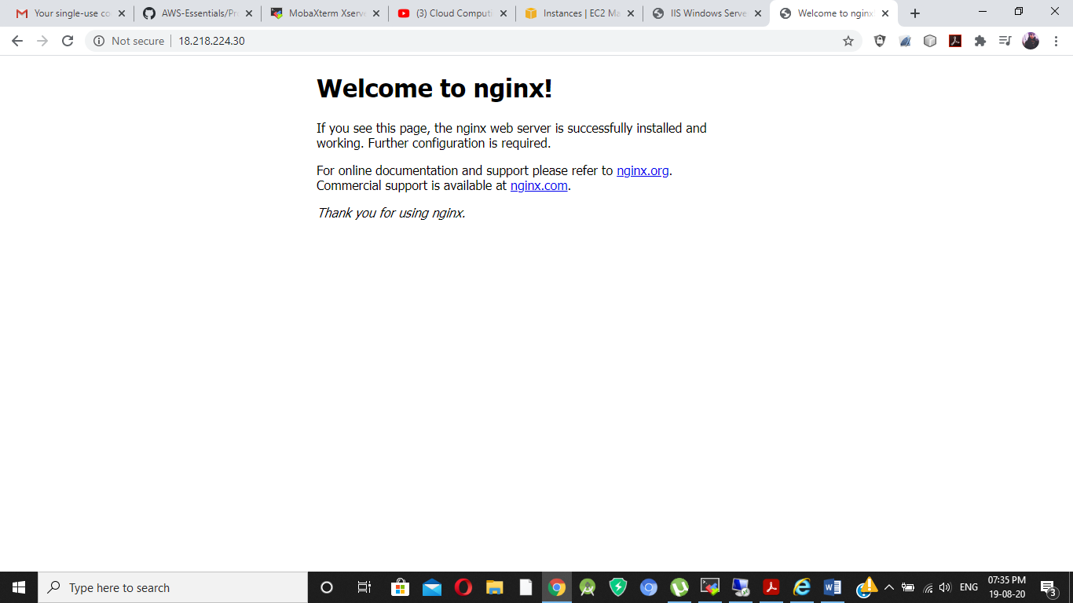

1. Linux Server Instance

Public IP - 18.191.141.108

